Charles Henderson

Reuel Maddela

Harpreet Sidhu

Activity 11

Say Hello method implemented: 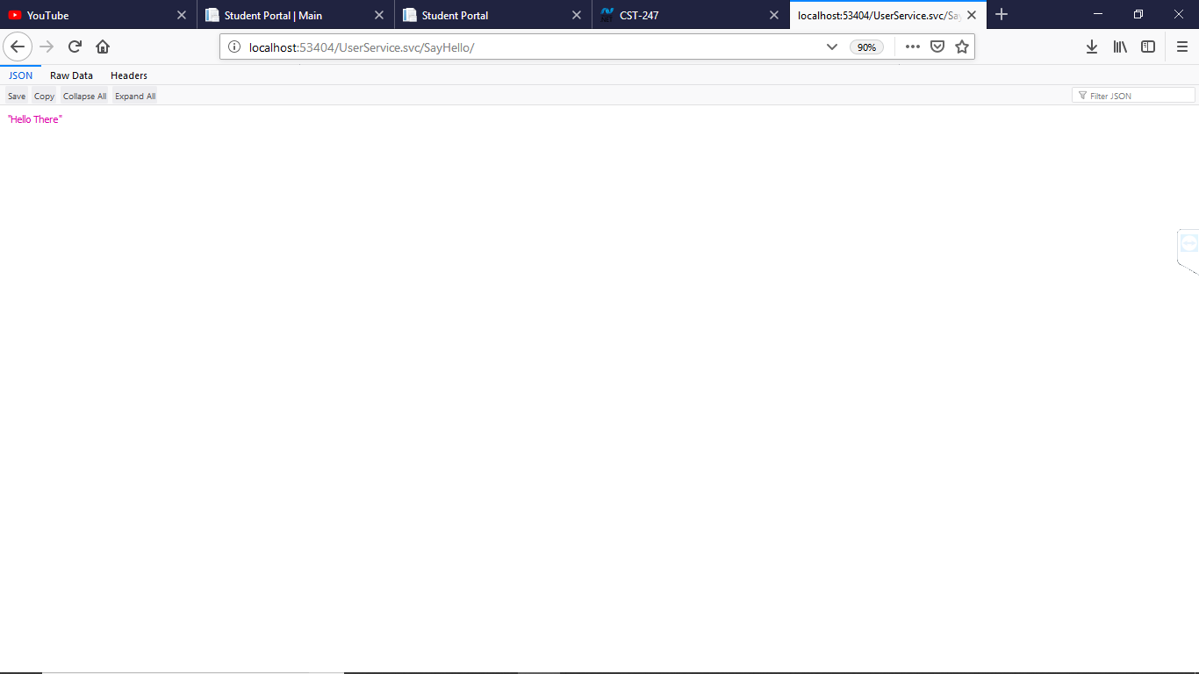

Get Data method implemented: 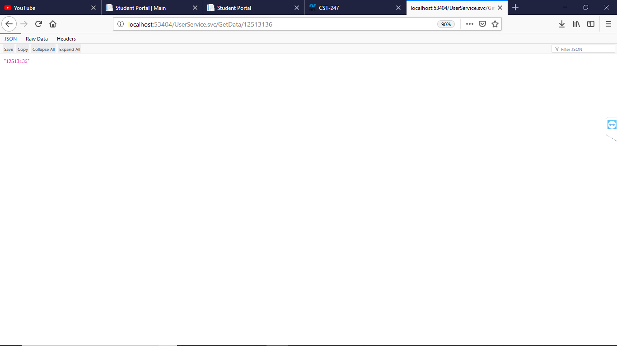

Get Object Model implemented: 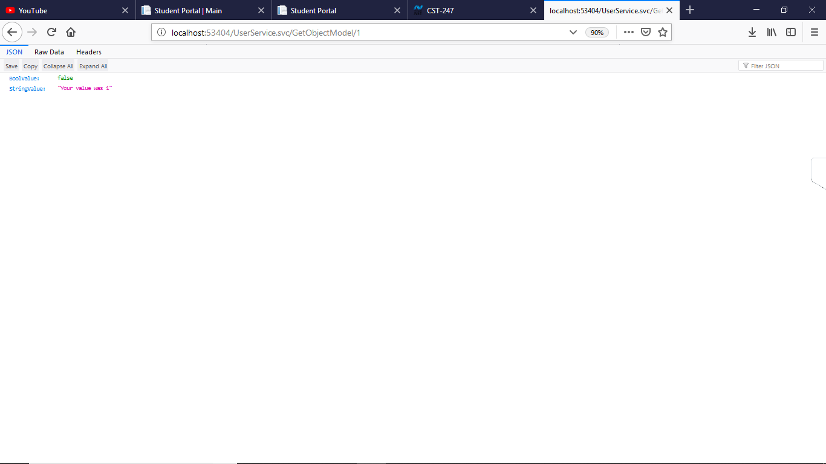

Get All Users method implemented with our names: 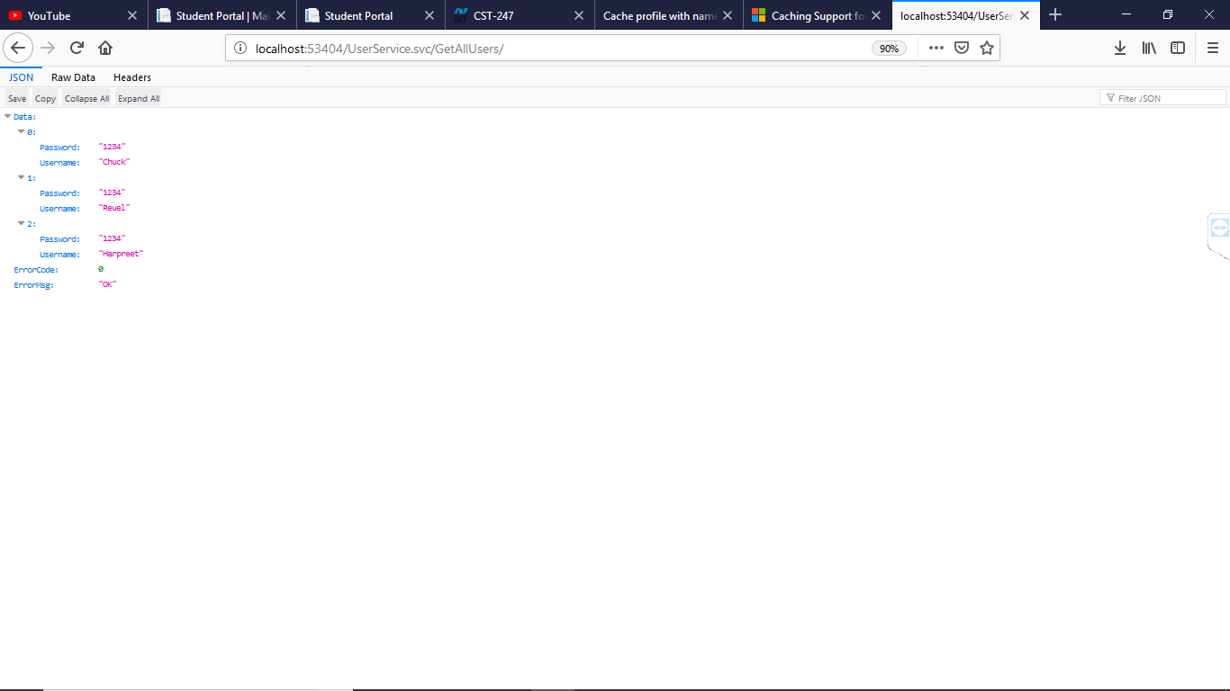

Retrieved user “1” in our users list: 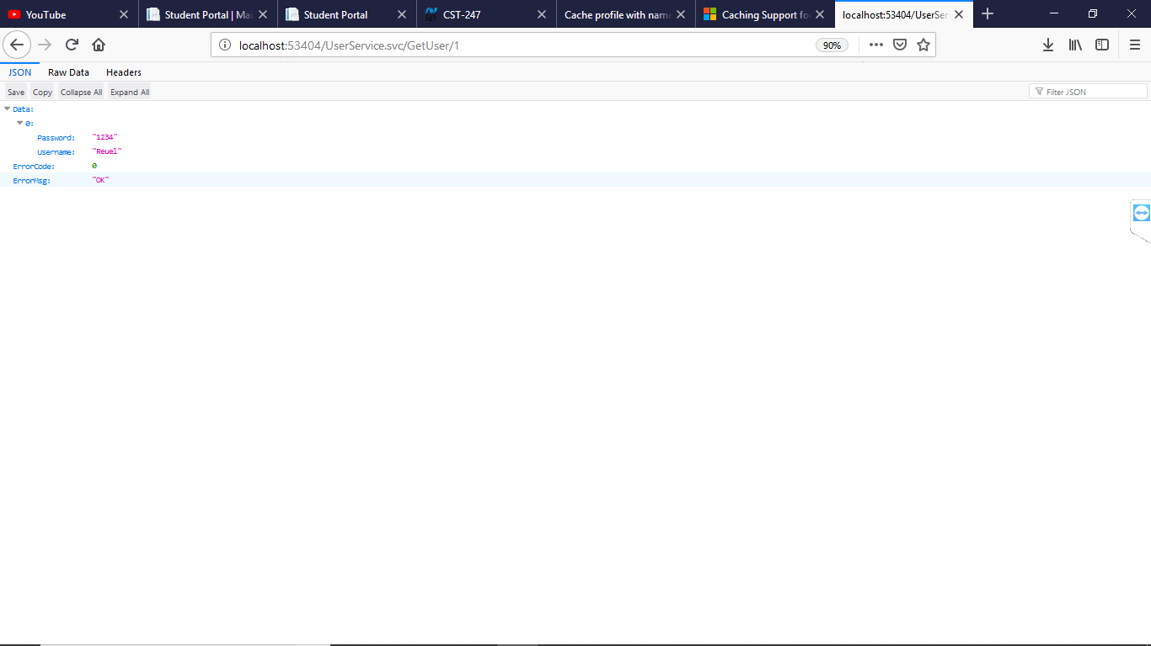

Tried to retrieve a user that does not exist: 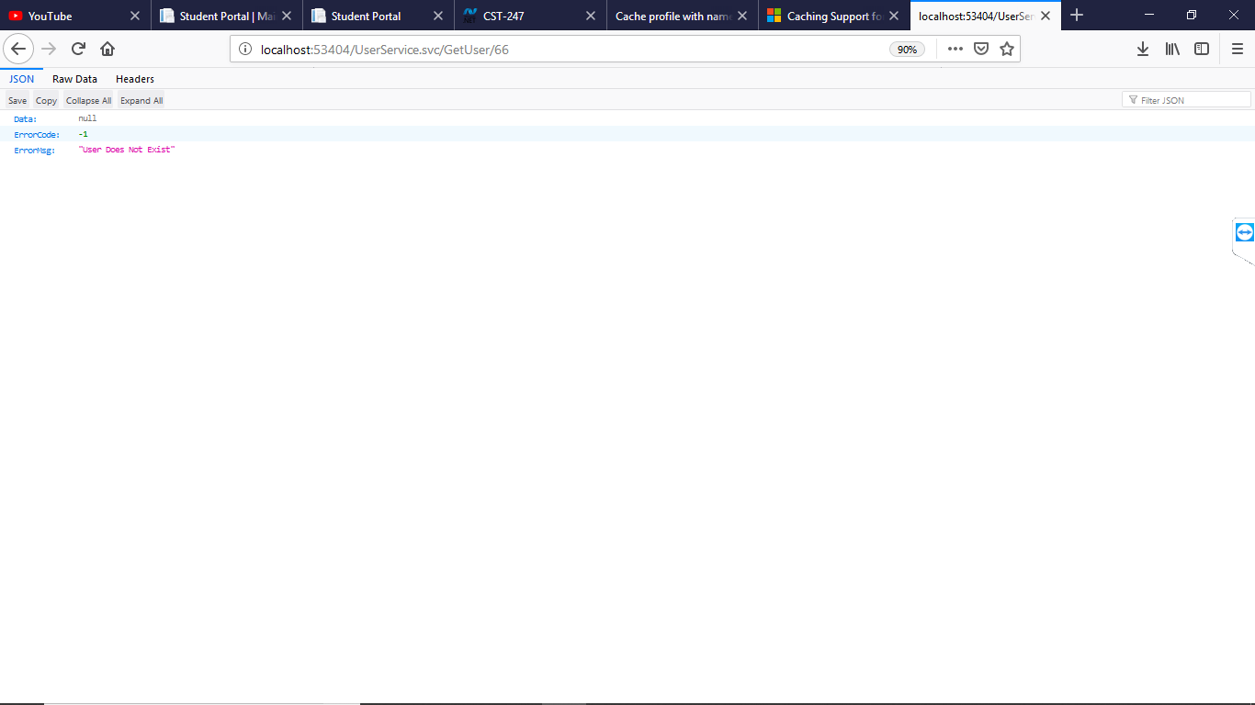

Get All Users method shown in JSON format within Postman: 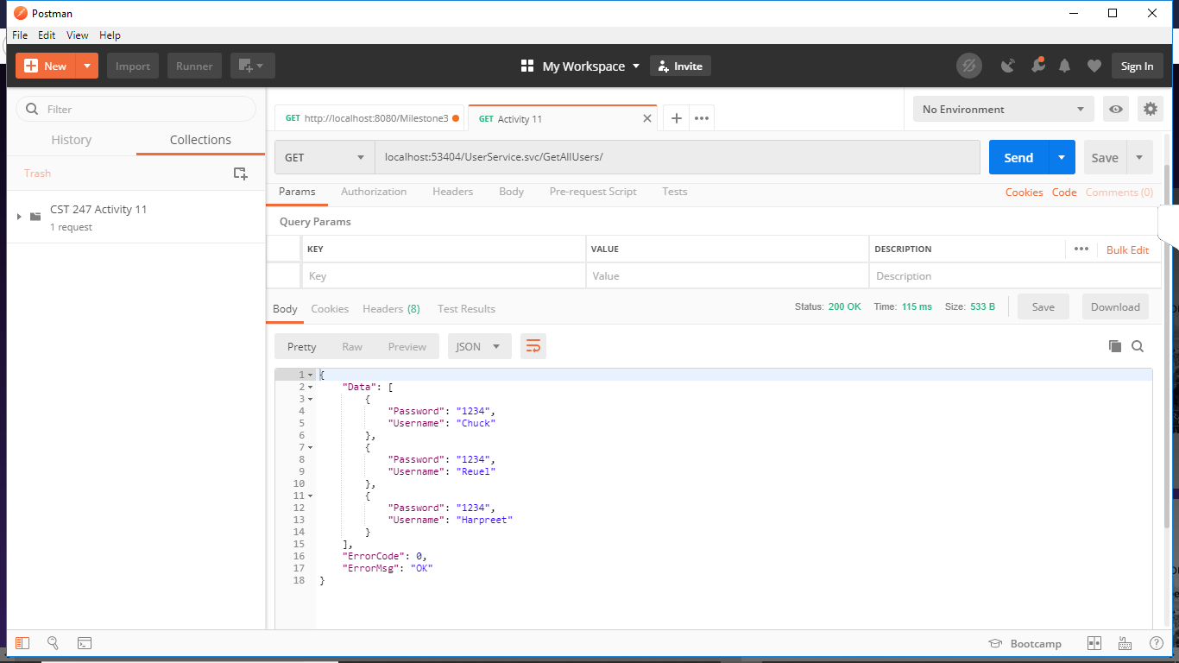

Get User method within Postman:

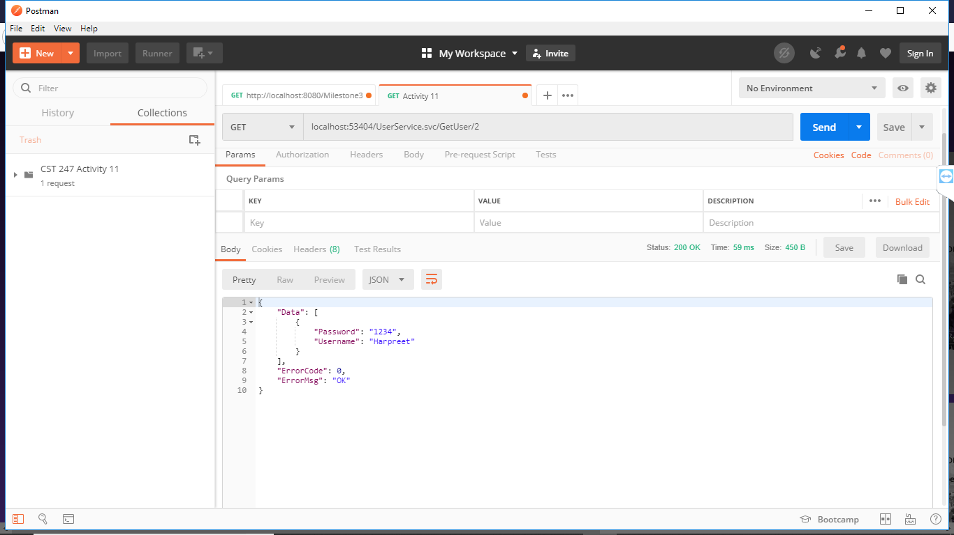

Searching for user that does not exist within Postman:

